Sunday | Monday | Tuesday | Wednesday |  | Thursday | Friday | Saturday
 |  |  |  | 1  May Day | 2 | 3 | 4
5  Cinco de Mayo | 6 | 7 |  | 8 | 9 | 10 | 11
12  Mother’s Day  National Skilled Nursing Care Week | 13 | 14 |  | 15 | 16 | 17 | 18  Armed Forces Day
19 | 20  Victoria Day (Canada) | 21 |  | 22 | 23 | 24 | 25
26 | 27  Memorial Day | 28 |  | 29 | 30 | 31

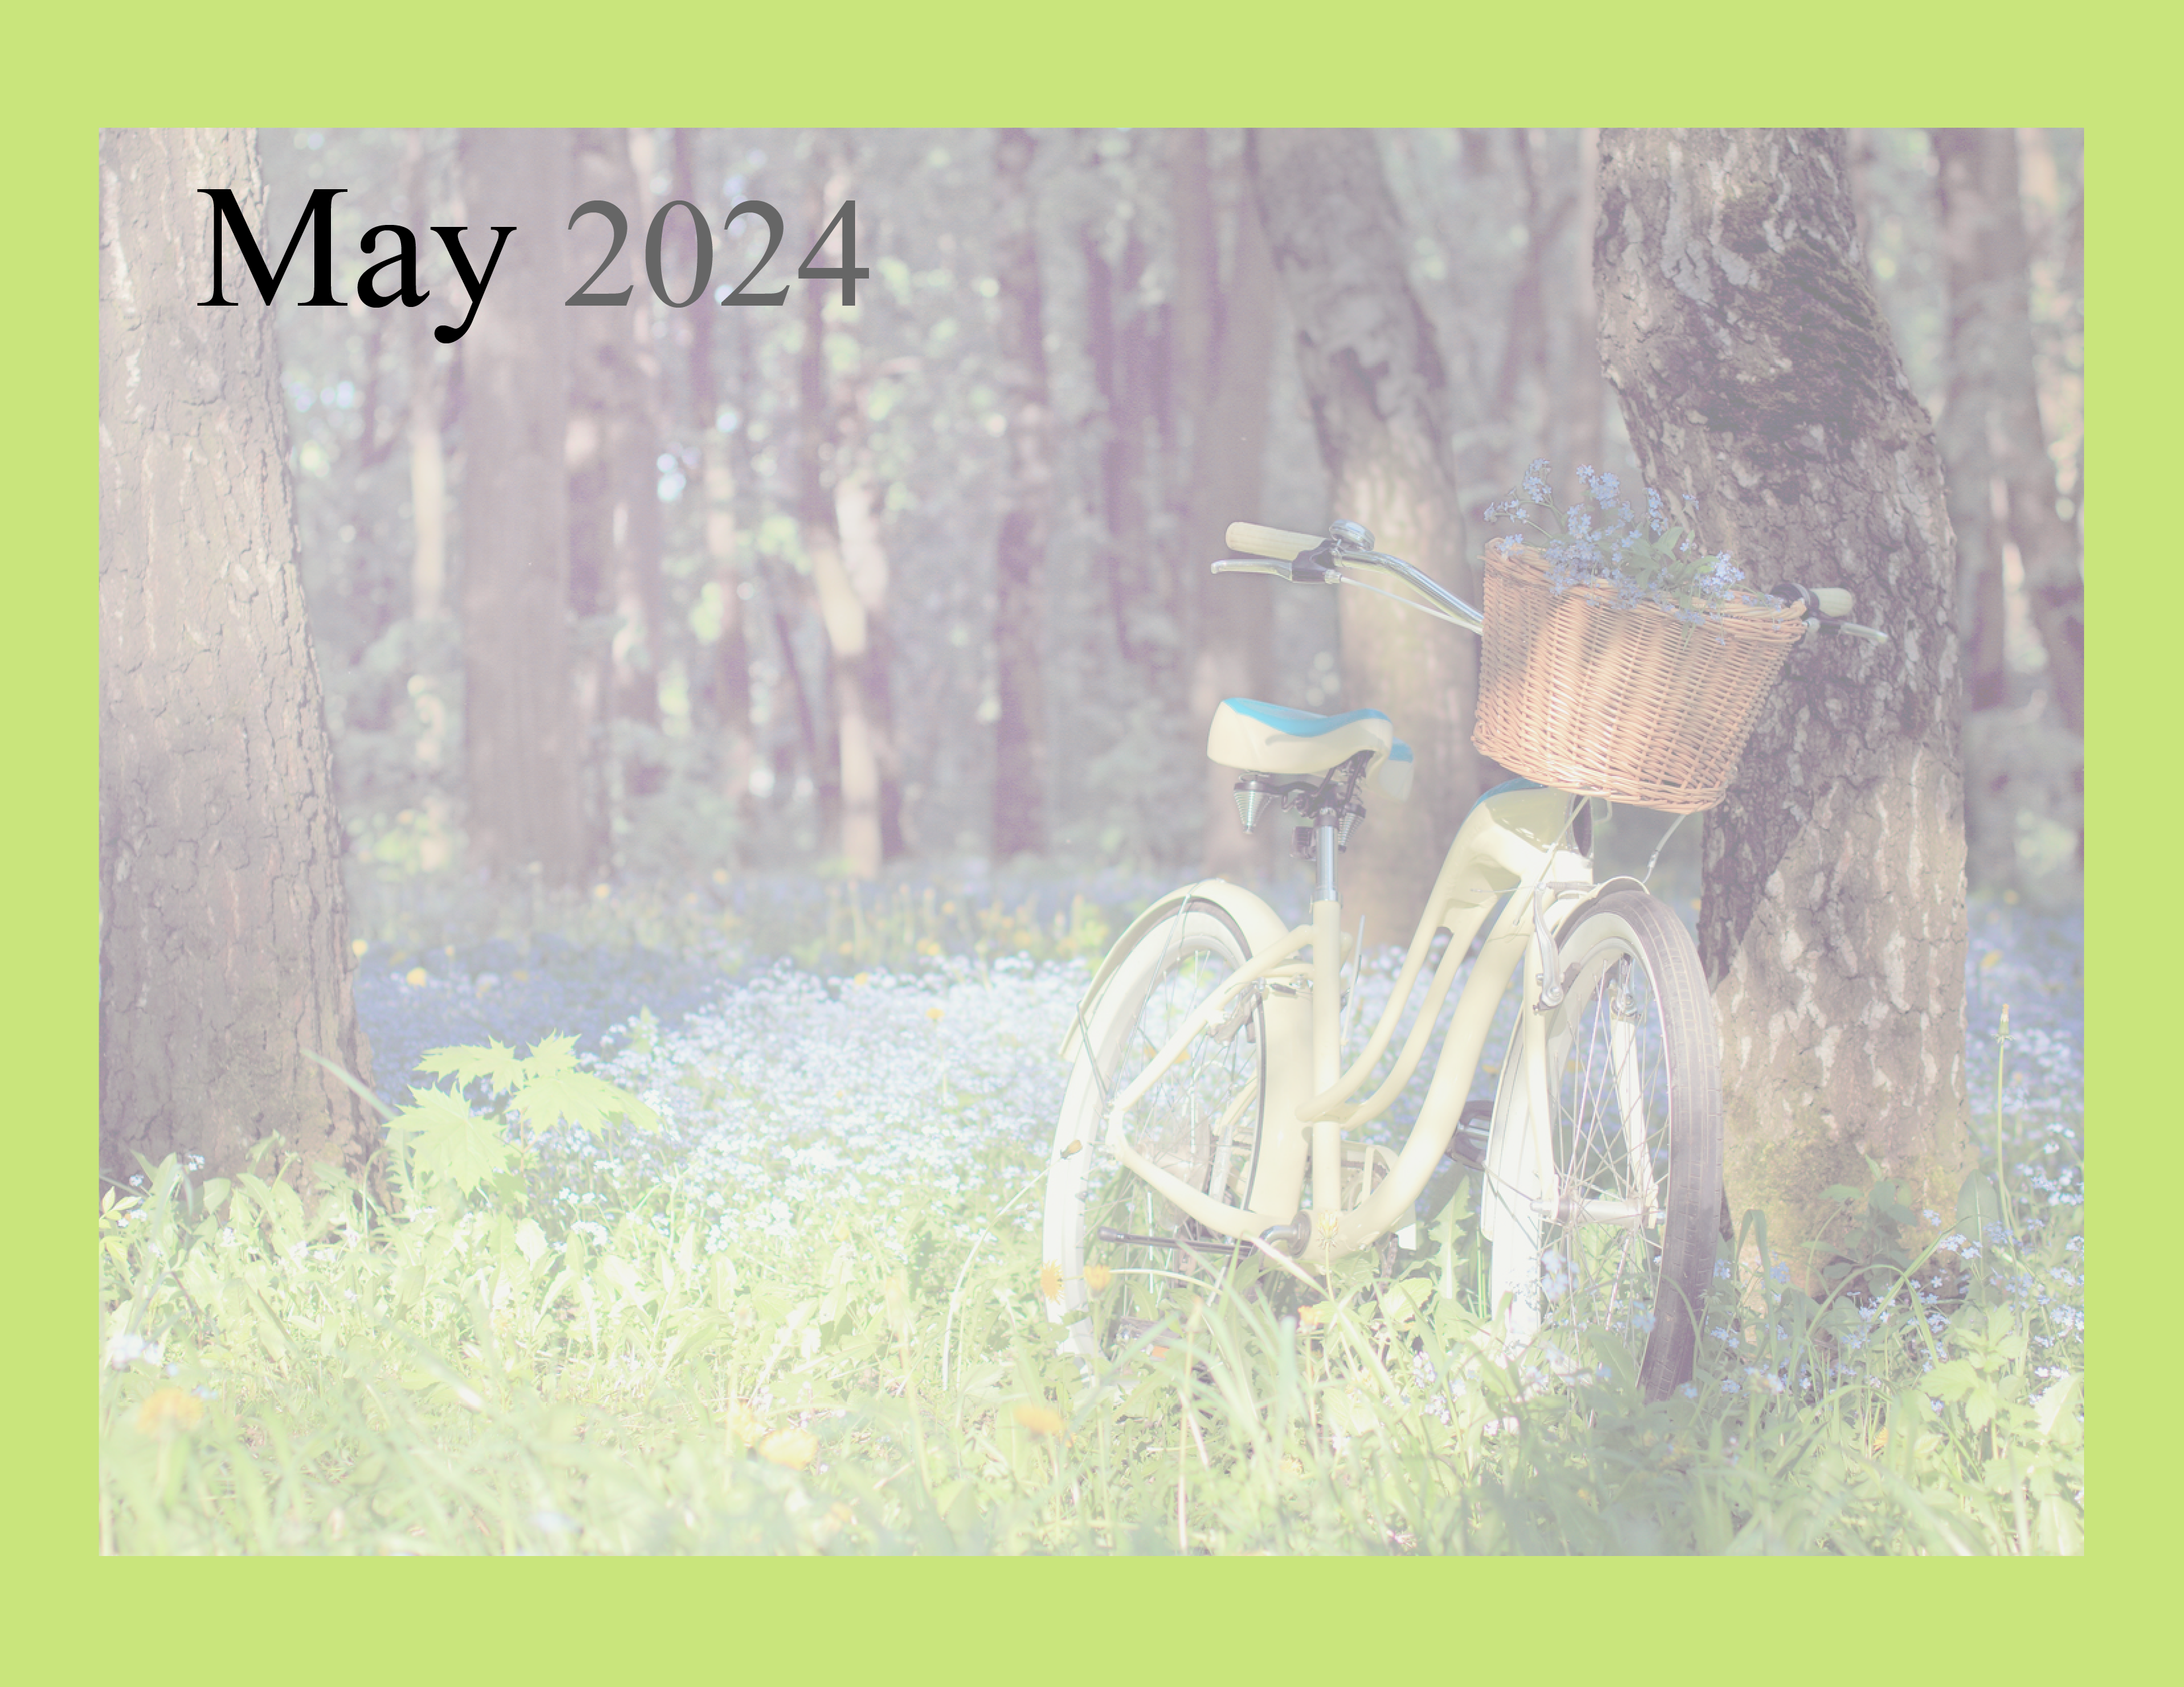  ST. AGNES ADULT DAY CENTER |  |  | Feel Good Stories  Art Class  What is the Correct Spelling? | CLOSED | May Crowning w/ 1st grade  Horse Races  Racing History | CLOSED
CLOSED | Woodworking  Tic Tac Oh NO!  Drive – In Movies  Can You C It? | Art Class  Picture This  Card Bingo | Mixed Up Things  The Sax Man Live! 10:30 | CLOSED | Do Your Manners Measure Up?  Favorite Baby Names  Talking ‘bout Mother’s Day | CLOSED
CLOSED | Rhyme Time  Woodworking  5 & Dime Stores  Bowling | Ponderings  Celebrity Chef  Birthday Party | Art Class  Reading Buddies | CLOSED | How Would You Handle This?  J. Jay Live! 10:30 | CLOSED
CLOSED | Wood working  Friendship to Treasure  What makes a Friend  Puzzle Race | Bunco  50 – Over or Under  Skeeball | Art Class  EZ Does It Trivia  Bean Bag Toss | CLOSED | Croquet  Ponderings  Outdoor Game Memories  Ballroom Dance 1PM | CLOSED
CLOSED | CLOSED | Beauty Shop  Memorial Day Program  Battleship | Smart Acronyms  Picture This  Art Class  Carry-in Luncheon families invited | CLOSED | Rhyme time  Graduation Memories  Toss the Hat | DAILY ACT.  Exercise  Devotions  Bingo  Physical games  Brain challenges  Music
www.stagnesvalpo.org Like us on FACEBOOK

